MONTGOMERY STREET SCHOOL
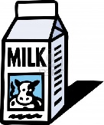
MILK PROGRAM

February 11, 2019

Dear Parents/Guardians,

Our third school milk program order will begin on Mon., March 11th and end Fri., June 7th.

The cost of the 237ml of milk for the 45 day period will be $18.00.
The days are calculated not including Wednesday’s, Holidays or Dist. Professional Development days.

If you wish for your child to participate in the milk program, please fill out the bottom of this letter and return it to the school. If you pay online you still need to send the order form in at the bottom of this letter and tick online payment.
The preferred payment is ONLINE payment. If cash or cheques are sent in for payment they have to be the correct amount. (cheques are payable to Montgomery Street School)
by Tuesday, February 19th

Milk will NOT be sold daily. Please choose below chocolate or white milk and which days you want it ordered for your child.

This is the last milk order for the year. Please note the date as you will have to provide a drink for your child after June. 7th with lunch.
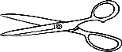

Cut here and return the bottom of this letter for ALL orders.
DUE ON Tuesday, February 19th

I would like to enroll __________________, in __________________’s class
(Student’s name) (Teacher’s name)
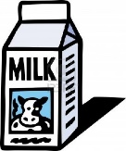
in the school milk program from March 11th - June 7th.

PLEASE CIRCLE: White or Chocolate

Monday | Tuesday | Thursday | Friday
White | White | White | White
Chocolate | Chocolate | Chocolate | Chocolate

Please
____ Payment of $ 18.00 was paid on line for milk

____ I am sending correct change or cheque payable to MSS for milk.

